Week 4 - Week commencing 21/2/2022

**Week Outline**

Online meeting discussing the implications and further analysis of the beam filling factor on the measured data from the detector.

The detector has a large solid angle, and thus the full beam of the detector is not entirely comprised of the radiance of the hot bar. An example diagram is given below:

Side view

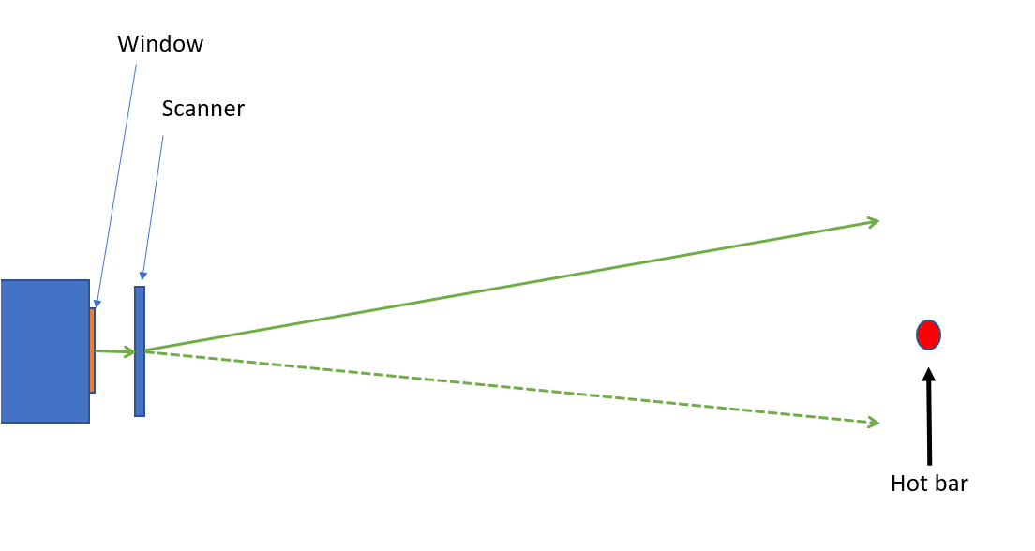

Front View

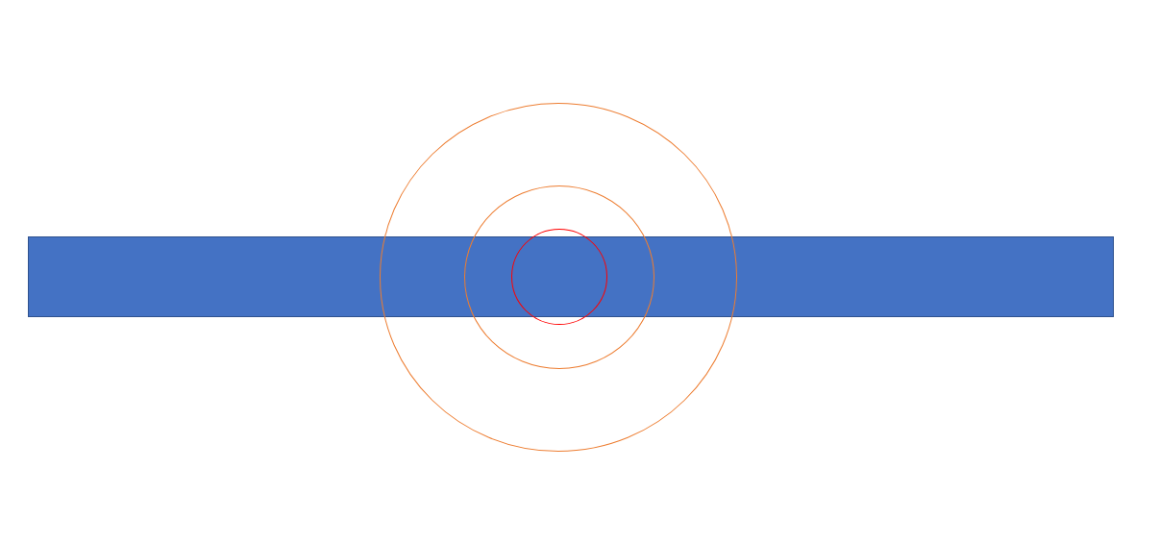where the red circle is the beam. As observed, the beam covers parts of the detection that goes beyond the hotbar, and you can imagine that the 2-D Gaussian dF0 peak that forms from the detection for a given detector data at a given time comprises of “addition of power” from background sources and that not 100% of the peak of the curve used for calculating the response corresponds to the hot bar. This leads to the idea of a beam filling factor.

The 2D Gaussian corresponding to the detection of the hot bar can be modelled in such a way that if we use and “cut” a 2D Gaussian of length2, to only the dimensions of the hot bar and set the outside of the curve to equal to 0. This is shown below:

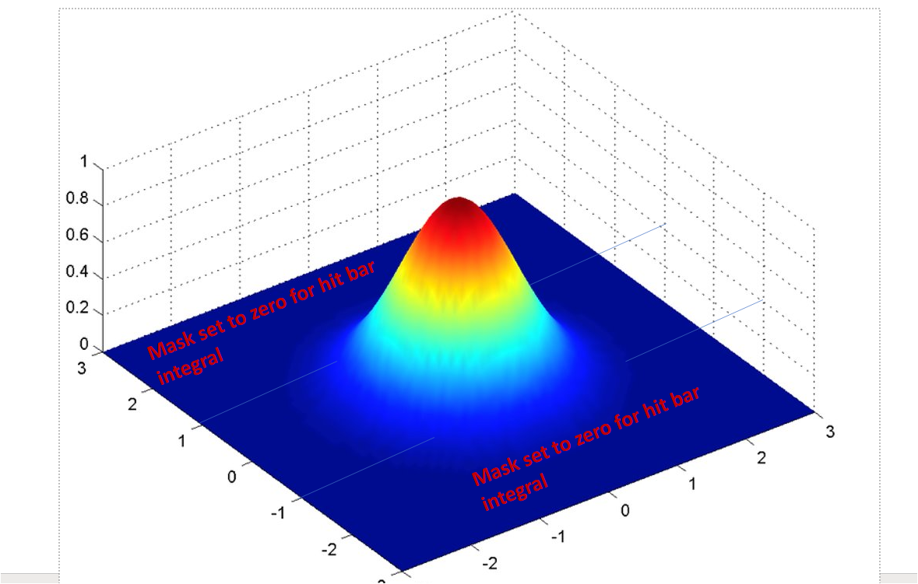  
  
We can then take the sum of the “cut” Gaussian curve and the “uncut” Gaussian curve and take the ratio of them, this gives a “Beam Filling Factor”:

$$BFF=\frac{\sum{hot bar Gaussian}}{\sum{2D Gaussian}}$$

This beam filling factor essentially gives a ratio of the beam that is filled by the hot bar. This will be essential in calculating the power of the hot bar in the following weeks to find the NEP.

**Complete Python Code Attached at the End of Diary**

**Tasks Outline**

* Create a 2D Gaussian Curve with amplitude 1, fwhm = width of hot bar and plot this for the length of the hot bar squared.
* Take the sum of this Gaussian as Gaussian_Sum
* Set the points outside the hot bar dimensions as equal to 0
* Take the sum of this new “cut” Gaussian.
* Take the ratio of Gaussian_Sum to “cut” Gaussian sum as the Beam Filling Factor.

**Top Down View of the cut Gaussian**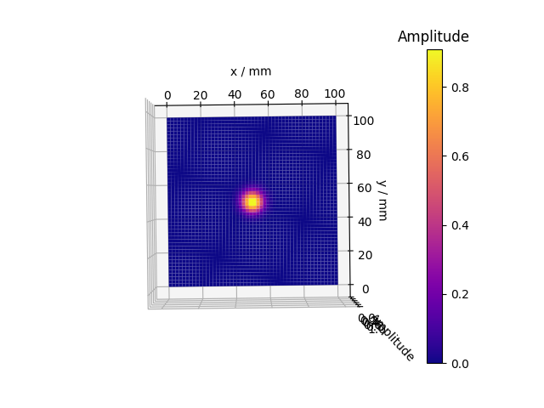

**Side View of the Cut Gaussian**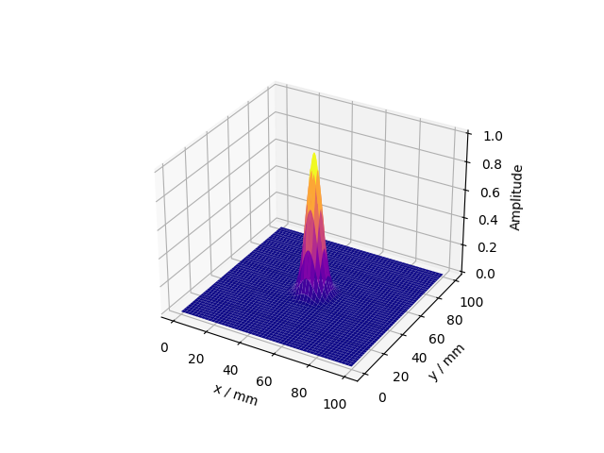

Beam Filling Factor was found to be: 0.9847